**Characteristics of Semiconductor junction Diode**

**What is diode?**

* In general, all the electronic devices need DC power supply but it is impossible to generate DC power so, we need an alternative to get some DC power thus the usage of diodes comes into the picture to convert AC power to DC power.
* **A diode is a tiny electronic component used in almost all the electronic circuits to enable the flow of current in only one direction** (*unidirectional device*).
* We can say that the usage of semiconductor materials to build the electronic components was started with diodes.
* Few applications of diodes are
* rectification, amplification, electronic switch, conversion of electrical energy into light energy and light energy into electrical energy.

Solid materials are generally classified into three types namely

* + **conductors,**
  + **insulators and**
  + **semi-conductors**.
* Conductors have a maximum number of free electrons, Insulators have a minimum number of free electrons (negligible such that flow of current is not at all possible)
* where as **semi-conductors** can be either conductors or insulators depending upon the potential applied to it.
* Semi-conductors which are in general use are **Silicon and Germanium**.
* *Silicon is preferred because it is abundantly available on the earth and it gives a better thermal range.*

Semi-conductors are further classified into two types as *Intrinsic and Extrinsic semi-conductors.*

* **Intrinsic Semi-conductors:**
* These are also called as pure semi-conductors where charge carriers (electrons and holes) are in equal quantity at the room temperature. So current conduction takes place by both holes and electrons equally.
* **Extrinsic Semiconductors:**
* In order to increase the number of holes or electrons in a material, we go for extrinsic semi-conductors where impurities (other than silicon and germanium or simply trivalent or pentavalent materials) are added to the silicon. This process of adding impurities to the pure semi-conductors is called as *Doping.*

**Formation of P and N-type semiconductors:**

**N-Type Semiconductor:**

* If pentavalent elements (number of valence electrons are five) are added to the Si or Ge then there are free electrons are available. As the electrons are more in number these are called as *N-type semiconductor*. In N-type, semi-conductor electrons are majority charge carriers and holes are minority charge carriers.Few pentavalent elements are **Phosphorous, Arsenic, Antimony, and Bismuth**. these elements are called as ***Donors***.

**P-Type Semiconductor**

* Similarly, if trivalent elements like Boron, Aluminium, Indium, and Gallium are added to Si or Ge, a hole is created because a number of valence electrons in it are three. Since a hole is ready to accept an electron and get paired it is called as ***Acceptors*.** As the number of holes are excess in newly formed material these are called as ***P-type semiconductors***. In P-type semi-conductor holes are majority charge carriers and electrons are minority charge carriers.

**P-N Junction Diode**

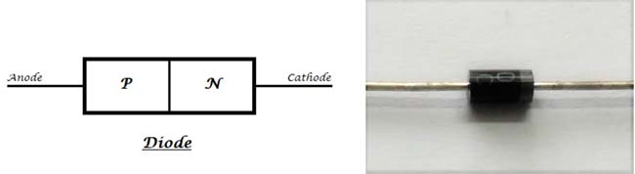

* Now, if we **join the two types of semi-conductors P-type and N-type together** then a new device is formed called as **P-N junction diode**. As the newly formed component can have two terminals or electrodes (one connected to P-type and the other to the N-type)
* The terminal connected to P-type material is called *Anode* and the terminal connected to N-type material is called *Cathode*.The **symbolic representation of the diode** is as follows.

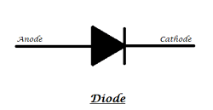

* The arrow indicates the flow of current through it when the diode is in forward biased mode, the dash or the block at the tip of the arrow indicates the blockage of current from the opposite direction.
* **Zero Bias:** No external voltage is applied.
* **Forward Bias:** External voltage decreases the built-in potential barrier.
* **Reverse Bias:** External voltage increases the built-in potential barrier.

**PN Junction Diode When No External Voltage is Applied**

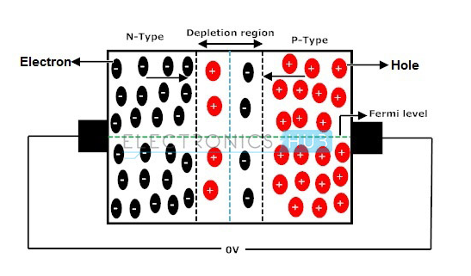

* In zero bias or thermal equilibrium state junction potential provides higher potential energy to the holes on the P-side than the N-side. If the terminals of junction diode are shorted, few majority charge carriers (holes) in the P side with sufficient energy to surmount the potential barrier travel across the depletion region. Therefore, with the help of holes, current starts to flow in the diode and it is referred to as forward current. In the similar manner, holes in the N side move across the depletion region in reverse direction and the current generated in this fashion is referred to as reverse current.Potential barrier opposes the migration of electrons and holes across the junction and allow the minority charge carriers to drift across the PN junction. As a result of it, a state of equilibrium is established when the majority charge carriers are equal in concentration on either side of the junction and when minority charge carriers are moving in opposite directions. A net zero current flows in the circuit and the junction is said to be in dynamic equilibrium. By increasing the temperature of semiconductors, minority charge carriers have been continuously generated and thereby leakage current starts to rise. In general no conduction of electric current takes place because no external source is connected to the PN junction.

**Forward Biased PN Junction Diode**

* With the externally applied voltage, a potential difference is altered between the P and N regions.When positive terminal of the source is connected to the P side and the negative terminal is connected to N side then the junction diode is said to be connected in forward bias condition. Forward bias lowers the potential across the PN junction.

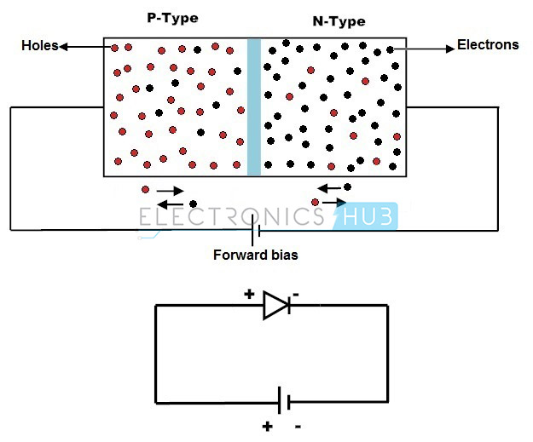

* The majority charge carriers in N and P regions are attracted towards the PN junction. the width of the depletion layer decreases with diffusion of the majority charge carriers. With the increase in forward bias greater than the built in potential, at a particular value the depletion region becomes very much thinner so that a large number of majority charge carriers can cross the PN junction and conducts an electric current. The current flowing up to built in potential is called as ZERO current or KNEE current.

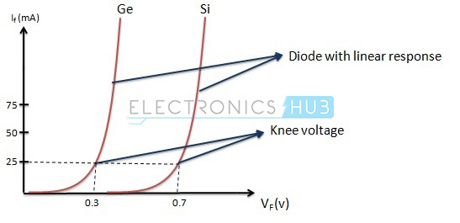

* With the increase in applied external forward bias, the width of the depletion layer becomes thin and forward current in a PN junction diode starts to increase abruptly after the KNEE point of forward I-V characteristic curve. The forward characteristic of a PN junction diode is non linear, i.e., not a straight line. This type of forward characteristic shows that resistance is not constant during the operation of the PN junction.The slope of the forward characteristic of a PN junction diode will become very steep quicklyThis shows that resistance is very low in forward bias of the junction diode The value of forward current is directly proportional to the external power supply and inversely proportional to the internal resistance of the junction diode.Applying forward bias to the PN junction diode causes a low impedance path for the junction diode, allows for conducting a large amount of current known as infinite current.
* This large amount current starts to flow above the KNEE point in the forward characteristic with the application of a small amount of external potential. The potential difference across the junction is maintained constant by the action of depletion layer. The maximum amount of current to be conducted is kept limited by the load resistor, because when the diode conducts more current than the usual specifications of the diode, the excess current results in the dissipation of heat and also leads to severe damage of the device.

**Reverse Biased PN Junction Diode**

* When positive terminal of the source is connected to the N side and the negative terminal is connected to P side, then the junction diode is said to be connected in reverse bias condition.
* In this type of connection majority charge carriers are attracted away from the depletion layer by their respective battery terminals connected to PN junction.

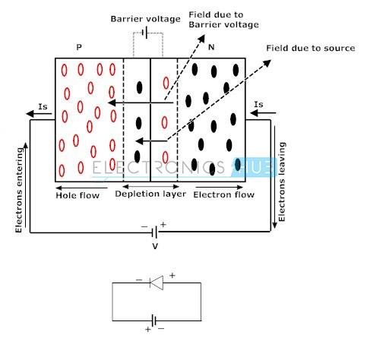

* Positive terminal attracts the electrons away from the junction in N side and negative terminal attracts the holes away from the junction in P side.
* As a result of it, the width of the potential barrier increases that impedes the flow of majority carriers in N side and P side. The width of the free space charge layer increases, thereby electric field at the PN junction increases and the PN junction diode acts as a resistor. But the time of diode acting as a resistor is very low. There will be no recombination of majority carriers taken place at the PN junction; thus, no conduction of electric current. The current that flows in a PN junction diode is the small leakage current, due to minority carriers generated at the depletion layer or minority carriers which drift across the PN junction. Finally, the result is that the growth in the width of the depletion layer presents a high impedance path which acts as an insulator.
* In reverse bias condition, no current flows through the PN junction diode with increase in the amount of applied external voltage. However, leakage current due to minority charge carriers flows in the PN junction diode that can be measured in micro amperes.
* As the reverse bias potential to the PN junction diode increases ultimately leads to PN junction reverse voltage breakdown and the diode current is controlled by external circuit. Reverse breakdown depends on the doping levels of the P and N regions.
* With the increase in reverse bias further, PN junction diode become short circuited due to overheat in the circuit and maximum circuit current flows in the PN junction diode.

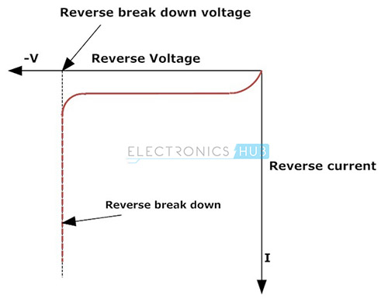

**V-I Characteristics of PN Junction Diode**

* 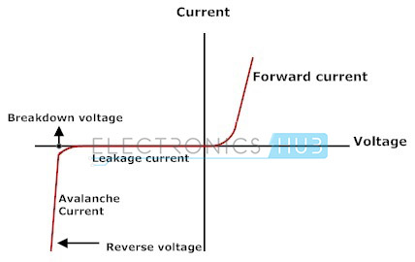
* The reverse bias characteristic curve of diode is shown in the fourth quadrant of the figure above.
* The current in the reverse bias is low till breakdown is reached and therefore the diode looks like as open circuit. When the reverse bias input voltage has reached the breakdown voltage, reverse current increases spectacularly.
* The forward bias characteristic curve of diode is shown in the first quadrant in the figure
* the current in the forward bias is incredibly low if the input voltage applied to the diode is lower than the threshold voltage (Vr). The threshold voltage is additionally referred to as cut-in voltage.
* Once the forward bias input voltage surpasses the cut-in voltage (0.3 V for germanium diode, 0.6-0.7 V for silicon diode), the current spectacularly increases, as a result the diode functions as short-circuit.

**Characteristics of Zener Diode**

* Let us learn about this exciting and unique kind of diode. Zener diodes are heavily doped than ordinary diodes.They have extra thin depletion region.
* When we apply a voltage more than the [Zener breakdown](https://www.electrical4u.com/zener-breakdown/) voltage (can range from 1.2 volts to 200 volts), the depletion region vanishes, and large current starts to flow through the junction. There is a crucial difference between an ordinary diode and a Zener diode.
* The depletion region regains its original position after removal of the reverse voltage in Zener diode whereas in regular diodes, they don’t, and hence they get destroyed.
* Here is the Zener diode symbol

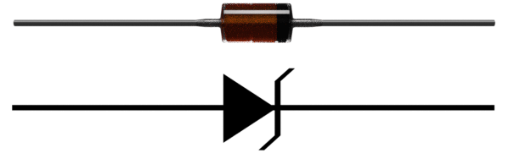

* Let us now look at the **Zener diode characteristic**:

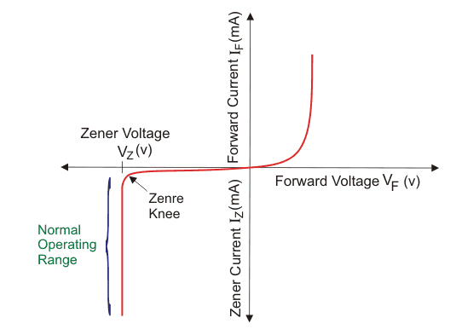

* A graph of current vs the [voltage](https://www.electrical4u.com/voltage-or-electric-potential-difference/) across the device is called the **characteristic of Zener diode**. The first quadrant is the forward biased region. Here the Zener diode acts like an ordinary [diode](https://www.electrical4u.com/diode-working-principle-and-types-of-diode/). When a forward voltage is applied, [current](https://www.electrical4u.com/electric-current-and-theory-of-electricity/) flows through it. But due to higher doping concentration, higher current flows through the [Zener diode](https://www.electrical4u.com/what-is-zener-diode/).In the third quadrant, The graph shows the current vs voltage curve when we apply a reverse bias to the diode. The Zener breakdown voltage is the reverse bias voltage after which a significant amount of current starts flowing through the Zener diode.Here in the diagram, VZ refers to the Zener breakdown voltage. Until the voltage reaches Zener breakdown level, tiny amount of current flows through the diode. Once the reverse bias voltage becomes more than the [Zener breakdown](https://www.electrical4u.com/zener-breakdown/) voltage, a significant amount of current starts flowing through the diode due to Zener breakdown. The voltage remains at the Zener breakdown voltage value, but the current through the diode increases when the input voltage gets increased. Due to the unique property of Zener diode, the depletion region regains its original position when the reverse voltage gets removed. The [Zener diode](https://www.electrical4u.com/what-is-zener-diode/) doesn’t get damaged despite this massive amount of [current](https://www.electrical4u.com/electric-current-and-theory-of-electricity/) flowing through it. This unique functionality makes it very useful for many applications.As the [voltage](https://www.electrical4u.com/voltage-or-electric-potential-difference/) remains at the [Zener breakdown](https://www.electrical4u.com/zener-breakdown/) voltage, we use [Zener diodes for voltage regulation](https://www.electrical4u.com/zener-diode-as-voltage-regulator/). We use them in voltage stabilisers and various other protection circuits. We also use them in [clipping circuit](https://www.electrical4u.com/clipping-circuit/) and [clamping circuit](https://www.electrical4u.com/clamping-circuit/). They provide a low-cost solution for voltage regulation.Characteristics of transistor

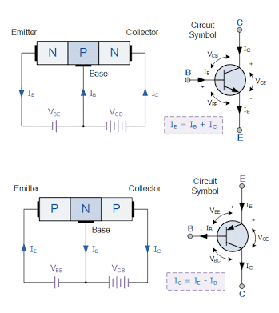

* The transistor is a three terminal device and consists of three distinct layers.
* Two of them are doped to give one type of semiconductor and the there is the opposite type, i.e. two may be n-type and one p-type, or two may be p-type and one may be n-type.. They are arranged so that the two similar layers of the transistor sandwich the layer of the opposite type.As a result these semiconductor devices are designated as either PNP transistors or NPN transistors according to the way they are made up.

**Transistor Characteristics**

Transistor Characteristics are the plots which represent the relationships between the [current](https://www.electrical4u.com/electric-current-and-theory-of-electricity/) and the [voltages](https://www.electrical4u.com/voltage-or-electric-potential-difference/) of a [transistor](https://www.electrical4u.com/bipolar-junction-transistor-or-bjt-n-p-n-or-p-n-p-transistor/) in a particular configuration.

By considering the transistor configuration circuits to be analogous to two-port networks, they can be analyzed using the characteristic-curves which can be of the following types

1. **Input Characteristics:** These describe the changes in input current with the variation in the values of input voltage keeping the output voltage constant.
2. **Output Characteristics:** This is a plot of output current versus output voltage with constant input current.
3. **Current Transfer Characteristics:** This characteristic curve shows the variation of output current in accordance with the input current, keeping output voltage constant.
4. **Common Base (CB) Configuration of Transistor**
5. **Common Collector (CC) Configuration of Transistor**
6. **Common Emitter (CE) Configuration of Transistor**

**Common Base (CB) Configuration of Transistor**

* In CB Configuration, the base terminal of the transistor will be common between the input and the output terminals as shown by Figure 1. This configuration offers low input impedance, high output impedance, high [resistance](https://www.electrical4u.com/electrical-resistance-and-laws-of-resistance/) gain and high voltage gain.

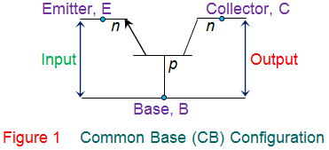

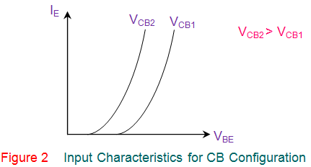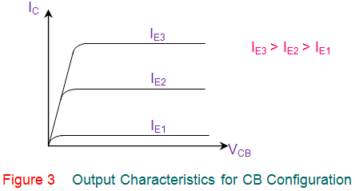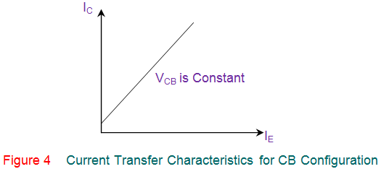

**Common Collector (CC) Configuration of Transistor**

* This transistor configuration has the collector terminal of the transistor common between the input and the output terminals (Figure 5) and is also referred to as emitter follower configuration. This offers high input impedance, low output impedance, voltage gain less than one and a large current gain.

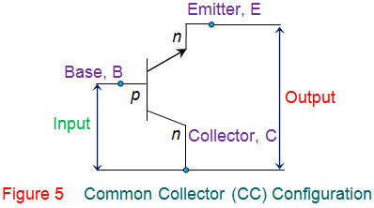

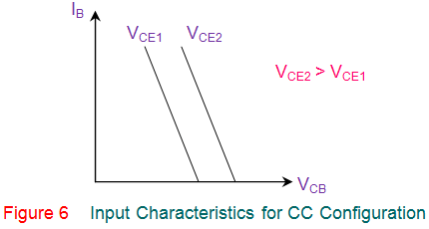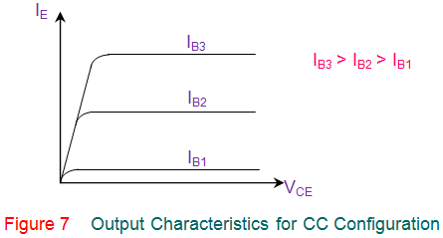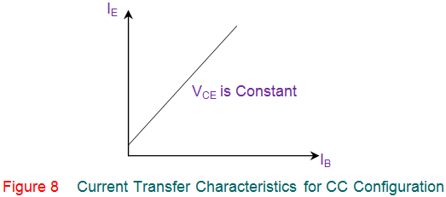

**Common Emitter (CE) Configuration of Transistor**

* In this configuration, the emitter terminal is common between the input and the output terminals as shown by Figure 9. This configuration offers medium input impedance, medium output impedance, medium current gain and voltage gain.

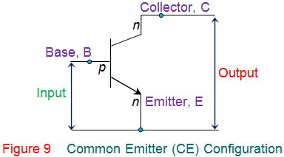

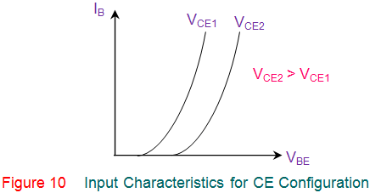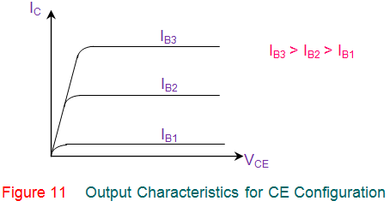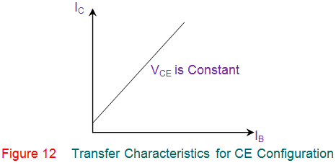

**Junction Field Effect Transistors**

* Field effect transistors (FETs) are usually termed as unipolar transistors because these FETs operations are involved with single-carrier type. The field effect transistors are categorized into different types such as a MOSFET, JFET, DGMOSFET, FREDFET, HIGFET, QFET, and so on. junction field effect transistor is one type of FETs which is used as a switch that can be controlled electrically. Through the active channel, electric energy will flow from between the source terminal and drain terminal. If the gate terminal is supplied with reverse bias voltage, then the flow of current will be completely switched off and the channel gets strained. The junction field effect transistor is generally classified into two types based on their polarities and they are:
  + 1. N-Channel junction field effect transistor
    2. P-Channel junction field effect transistor

**N-Channel Junction Field Effect Transistor**

* The JFET in which electrons are primarily composed as the charge carrier is termed as N-channel JFET. Hence, if the transistor is turned on, then we can say that the current flow is primarily because of the [movement of electrons](https://www.elprocus.com/vi-characteristics-of-pn-junction-diode/).

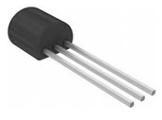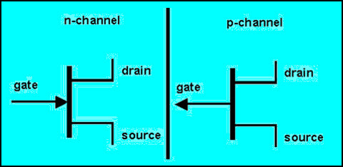

**P-Channel Junction Field Effect Transistor**

* The JFET in which holes are primarily composed as the charge carrier is termed as P-channel JFET. Hence, if the transistor is turned on, then we can say that the current flow is primarily because of the holes.

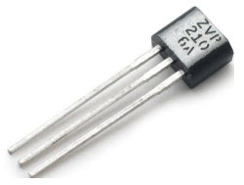

**N-Channel Operation of JFET**

* For turning ON a N-channel JFET, positive voltage of VDD has to be applied to the drain terminal of the transistor w.r.t (with respect to) source terminal such that the drain terminal must be appropriately more positive than the source terminal. Thus, current flow is allowed through the drain to source channel. If the voltage at the gate terminal, VGG is 0V, then there will be maximum current at the drain terminal and N-channel JFET is said to be in ON condition.

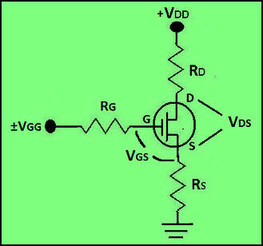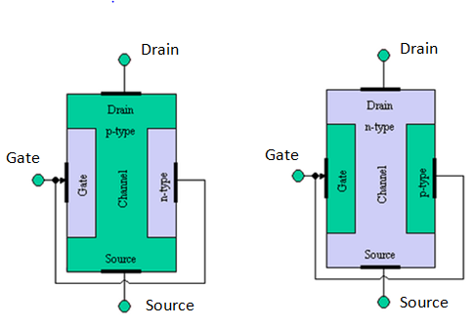

* **N-Channel JFET Characteristics**
* The N-channel JFET characteristics or transconductance curve is shown in the figure below which is graphed between drain current and gate-source voltage. There are multiple regions in the transconductance curve and they are ohmic, saturation, cutoff, and breakdown regions.

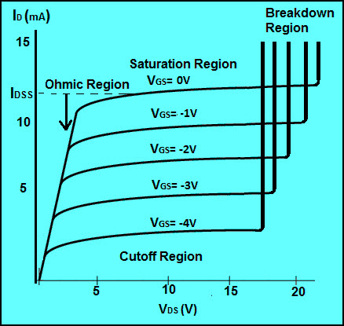

* For turning off the N-channel JFET, the positive bias voltage can be turned off or a negative voltage can be applied to the gate terminal. Thus, by changing the polarity of the gate voltage the drain current can be reduced and then N-channel JFET is said to be in OFF condition.



* **Ohmic Region**  
  The only region in which transconductance curve shows linear response and drain current is opposed by the JFET transistor resistance is termed as Ohmic region.
* **Saturation Region**  
  In the saturation region, the N-channel junction field effect transistor is in ON condition and active, as maximum current flows because of the gate-source voltage applied.
* **Cutoff Region**  
  In this cutoff region, there will be no drain current flowing and thus, the N-channel JFET is in OFF condition.
* **Breakdown Region**  
  If the VDD voltage applied to the drain terminal exceeds the maximum necessary voltage, then the transistor fails to resist the current and thus, the current flows from drain terminal to source terminal. Hence, the transistor enters into the breakdown region.



* For turning OFF the P-channel JFET, the negative bias voltage can be turned off or positive voltage can be applied to the gate terminal. If the gate terminal is given positive voltage, then the drain currents starts reducing (until cutoff) and thus the P-channel JFET is said to be in OFF condition.

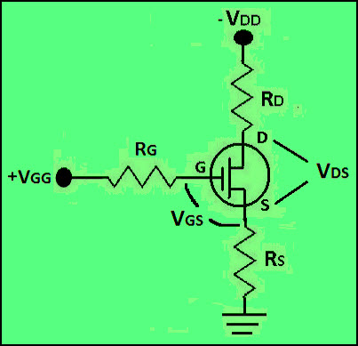

**P-Channel Operation of JFET**

* For turning ON P-channel JFET, negative voltage can be applied across the drain terminal of the transistor w.r.t source terminal such that the drain terminal must be appropriately more negative than the source terminal. Thus, the current flow is allowed through the drain to source channel. If the [voltage at the gate terminal](https://www.elprocus.com/silicon-controlled-rectifier-tutorial-and-characteristics/), VGG is 0V, then there will be maximum current at the drain terminal and the P-channel JFET is said to be in ON condition.



**P-Channel JFET Characteristics**

* The P-channel JFET characteristics or transconductance curve is shown in the figure below which is graphed between drain current and gate-source voltage. There are multiple regions in the transconductance curve and they are ohmic, saturation, cutoff, and breakdown regions.

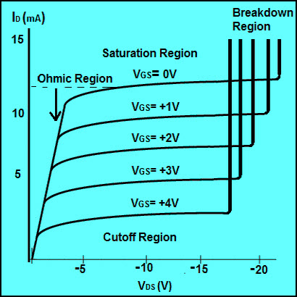

* **Ohmic Region**  
  The only region in which transconductance curve shows linear response and drain current is opposed by the JFET transistor resistance is termed as Ohmic region.
* **Saturation Region**  
  In the saturation region, the P-channel junction field effect transistor is in ON condition and active, as maximum current flows because of the gate-source voltage applied.
* **Cutoff Region**  
  In this cutoff region, there will be no drain current flowing and thus, the P-channel JFET is in OFF condition.
* **Breakdown Region**  
  If the VDD voltage applied to the drain terminal exceeds the maximum necessary voltage, then the transistor fails to resist the current and thus, the current will flow from drain terminal to source terminal. Hence, the transistor enters into the breakdown region.

Characteristics of UJT

**What is Unijunction Transistor (UJT)**

* UJT stands for **U**ni**J**unction **T**ransistor. It is a three terminal semiconductor switching device. The Unijunction Transistor is a simple device that consists of a bar of n-type silicon material with a non-rectifying contact at either end (base 1 and base 2), and with a rectifying contact (emitter) alloyed into the bar part way along its length, to form the only junction within the device (hence the name ‘Unijunction’).The Unijunction Transistor is also known as Double Base Diode.In Unijunction Transistor, the PN Junction is formed by lightly doped N type silicon bar with heavily doped P type material on one side.
* The ohmic contact on either ends of the silicon bar is termed as Base 1 (B1) and Base 2 (B2) and P-type terminal is named as emitter.The emitter junction is placed such that it is more close to terminal Base 2 than Base 1. The symbols of both UJT and JFET resemble the same except the emitter arrowhead represents the direction in which conventional current flow, but they operate differently

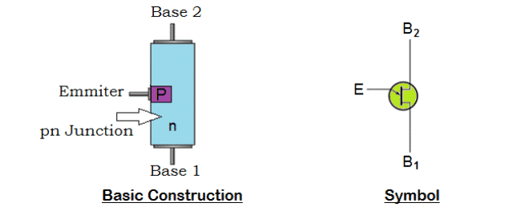

**How does a Unijunction Transistor (UJT) works**

* The simplified equivalent circuit shows that N-type channel consists of two resistors RB2 and RB1 in series with an equivalent diode, D representing the PN junction.
* The emitter PN junction is fixed along the ohmic channel during its manufacturing process.The variable resistance RB1 is provided between the terminals Emitter (E) and Base 1 (B1), the RB2 between the terminals Emitter (E) and Base 2 (B2). Since the PN junction is more close to B2, the value of RB2 will be less than the variable resistance RB1.A voltage divider network is formed by the series resistances RB2 and RB1.
* When a voltage is applied across the semiconductor device, the potential will be in proportion to the position of base points along the channel.

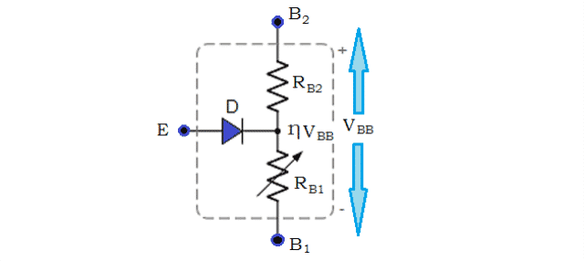

* The Emitter (E) will act as input when employed in a circuit, as the terminal B1 will be grounded. The terminal B2 will be positive biased to B1, when a voltage (VBB) applied across the terminals B1 and B2. When the emitter input is zero, the voltage across resistance RB1 of the voltage divider circuit is calculated by



* The important parameter of Unijunction Transistor is ‘intrinsic stand-off ratio’ (η), which is resistive ratio of RB1 to RBB. Most UJT’s have η value ranging from 0.5 to 0.8. The PN junction is reverse biased; when small amount of voltage which is less than voltage developed across resistance RB1 (ηVBB) is applied across the terminal emitter (E). Thus a very high impedance is developed prompting device to move into non-conducting state i.e., it will be switched off and no current flows through it. The UJT begins to conduct when the PN junction is forward biased.The forward biased is achieved when voltage applied across emitter terminal is increased and becomes more than VRB1. This results in larger flow of emitter current from emitter region to base region.
* Increase in emitter current reduces the resistance between emitter and Base 1, resulting in negative resistance at emitter terminal.The Unijunction Transistor (UJT) will act as voltage breakdown device, when the input applied between emitter and base 1 reduces below breakdown value i.e., RB1 increases to a higher value. This shows that RB1 depends on the emitter current and it is variable.

**Characteristics Curve of Unijunction Transistor (UJT)**

* The characteristics of Unijunction Transistor (UJT) can be explained by three parameters:
* Cutoff
* *Negative Resistance Region*
* *Saturation*

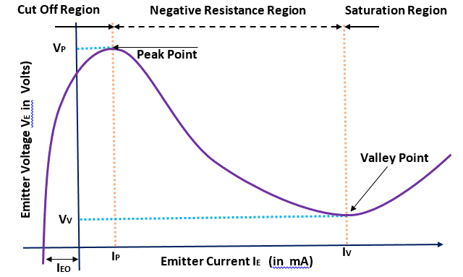

**Cutoff**

* Cutoff region is the area where the Unijunction Transistor (UJT) doesn’t get sufficient voltage to turn on. The applied voltage hasn’t reached the triggering voltage, thus making transistor to be in off state.

**Negative Resistance Region**

* When the transistor reaches the triggering voltage, VTRIG, Unijunction Transistor (UJT) will turn on. After a certain time, if the applied voltage increases to the emitter lead, it will reach out at VPEAK. The voltage drops from VPEAK to Valley Point even though the current increases (negative resistance).

**Saturation**

* Saturation region is the area where the current and voltage raises, if the applied voltage to emitter terminal increases.

**Applications of Unijunction Transistor (UJT)**

* The Unijunction Transistor can be employed in variety of applications such as:
* Switching Device
* Triggering Device for Triacs and SCR’s
* Timing Circuits
* For phase control
* In sawtooth generators
* In simple  relaxation oscillators

**Advantages of Unijunction Transistor (UJT)**

* The advantages of Unijunction Transistor include:
* low cost
* negative resistance characteristics
* Requires low value of triggering current.
* A stable triggering voltage
* Low power absorbing device

**Disadvantage of Unijunction Transistor (UJT)**

* The main disadvantage of Unijunction Transistor is its inability to provide appropriate amplification.

**Silicon Controlled Rectifier**

**Introduction**

* The Silicon Controlled Rectifier (SCR) is the most important and mostly used member of the thyristor family. SCR can be used for different applications like rectification, regulation of power and inversion, etc. Like a diode, SCR is a unidirectional device that allows the current in one direction and opposes in another direction.SCR is a three terminal device; anode, cathode and gate as shown in figure. SCR has built in feature to turn ON or OFF and its switching is controlled by biasing conditions and gate input terminal.This results in varying the average power delivered at the load , by varying the ON periods of the SCR. It can handle several thousands of voltages and currents. SCR symbol and its terminals are shown in figure.
* 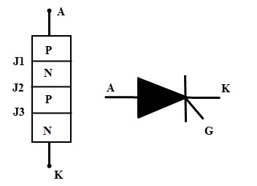

**Construction of Silicon Controlled Rectifier**

* The SCR is a four layer and three terminal device. The four layers made of P and N layers, are arranged alternately such that they form three junctions J1, J2 and J3. These junctions are either alloyed or diffused based on the type of construction.The outer layers (P and N-layers) are heavily doped whereas middle P and N-layers are lightly doped. The gate terminal is taken at the middle P-layer, anode is from outer P- layer and cathode is from N- layer terminals. The SCR is made of silicon because compared to germanium leakage current in silicon is very small.
* 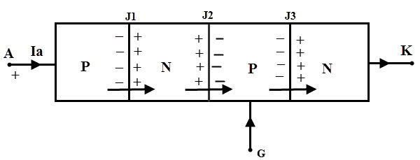

**Working or Modes of Operation of SCR**

* Depending on the biasing given to the SCR, the operation of SCR is divided into three modes. They are
* Forward blocking Mode
* Forward Conduction Mode and
* Reverse Blocking Mode

**Forward Blocking Mode**

* In this mode of operation, the Silicon Controlled Rectifier is connected such that the anode terminal is made positive with respect to cathode while the gate terminal kept open. In this state junctions J1 and J3 are forward biased and the junction J2 reverse biased.Due to this, a small leakage current flows through the SCR. Until the voltage applied across the SCR is more than the break over voltage of it, SCR offers a very high resistance to the current flow. Therefore, the SCR acts as a open switch in this mode by blocking forward current flowing through the SCR as shown in the VI characteristics curve of the SCR.
* 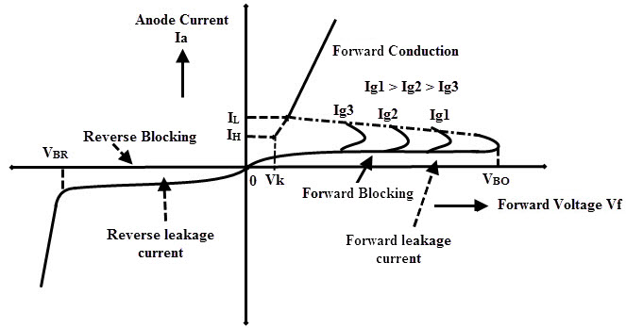

**Reverse Blocking Mode**

* In this mode of operation, cathode is made positive with respect to anode. Then the junctions J1 and J3 are reverse biased and J2 is forward biased. This reverse voltage drives the SCR into reverse blocking region results to flow a small leakage current through it and acts as an open switch as shown in figure.
* So, the device offers a high impedance in this mode until the voltage applied is less than the reverse breakdown voltage VBR of the SCR. If the reverse applied voltage is increased beyond the VBR, then avalanche breakdown occurs at junctions J1 and J3 which results to increase reverse current flow through the SCR.
* This reverse current causes more losses in the SCR and even to increase the heat of it. So there will be a considerable damage to the SCR when the reverse voltage applied more than VBR.

**Forward Conduction Mode**

* In this mode, SCR or thyristor comes into the conduction mode from blocking mode.
* It can be done in two ways as either by applying positive pulse to gate terminal or by increasing the forward voltage (or voltage across the anode and cathode) beyond the break over voltage of the SCR.Once any one of these methods is applied, the avalanche breakdown occurs at junction J2. Therefore the SCR turns into conduction mode and acts as a closed switch thereby current starts flowing through it.Note that in the VI characteristic figure, if the gate current value is high, the minimum will be the time to come in conduction mode as Ig3 > Ig2 > Ig1.
* In this mode, maximum current flows through the SCR and its value depends on the load resistance or impedance.It is also noted that if gate current is increasing, the voltage required to turn ON the SCR is less if gate biasing is preferred.
* The current at which the SCR turns into conduction mode from blocking mode is called as latching current (IL).And also when the forward current reaches to level at which the SCR returns to blocking state is called as holding current (IH). At this holding current level, depletion region starts to develop around junction J2. Hence the holding current is slightly less than the latching current.

**Advantages of Silicon Controlled Rectifier**

* As compared with electromechanical or mechanical switch, SCR has no moving parts. Hence, with a high efficiency it can deliver noiseless operation.
* The switching speed is very high as it can perform 1 nano operations per second.
* These can be operated at high voltage and current ratings with a small gate current.
* More suitable for AC operations because at every zero position of the AC cycle the SCR will automatically switch OFF.
* Small in size, hence easy to mount and trouble free service.

**Summary**

* The Silicon Controlled Rectifier behaves like a switch with two states that is either non-conducting or conducting.
* There are three modes in which SCR operates. Those are forward blocking, forward conduction mode and reverse blocking mode.
* There are mainly two ways to turn ON the SCR that means either by increasing the voltage across the SCR beyond the break over voltage of the SCR or by applying a small voltage to the gate. The typical value of the gate is 1.5 V, 30 mA .
* If the gate current is increased the SCR will turn ON at much reduced supply voltage.
* The SCR cannot be turned OFF through the gate so to open the SCR, applied voltage must reduced to zero.
* Silicon Controlled Rectifier can be used for both AC and DC switching applications.

**Rectifiers**

**What is a Half Wave Rectifier?**

* A **half wave rectifier** is defined as a [type of rectifier](https://www.electrical4u.com/rectifier-type-instrument-construction-principle-of-operation/) that only allows one half-cycle of an AC [voltage](https://www.electrical4u.com/voltage-or-electric-potential-difference/) waveform to pass, blocking the other half-cycle.
* Half-wave rectifiers are used to convert AC voltage to DC voltage, and only require a single [diode](https://www.electrical4u.com/diode-working-principle-and-types-of-diode/) to construct.
* A rectifier is a device that converts alternating current (AC) to direct current (DC).
* It is done by using a diode or a group of diodes. Half wave rectifiers use one diode, while a [full wave rectifier](https://www.electrical4u.com/full-wave-rectifiers/) uses multiple diodes.
* The working of a half wave rectifier takes advantage of the fact that diodes only allow [current](https://www.electrical4u.com/electric-current-and-theory-of-electricity/) to flow in one direction.

**Half Wave Rectifier Theory**

* A half wave rectifier is the simplest form of rectifier available.
* The diagram below illustrates the basic principle of a half-wave rectifier.
* When a standard AC waveform is passed through a half-wave rectifier, only half of the AC waveform remains.
* Half-wave rectifiers only allow one half-cycle (positive or negative half-cycle) of the AC voltage through and will block the other half-cycle on the DC side, as seen below.

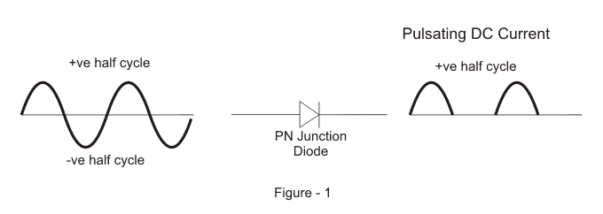

* Only one diode is required to construct a half-wave rectifier.
* Since DC systems are designed to have current flowing in a single direction putting an AC waveform with positive and negative cycles through a DC device can have destructive (and dangerous) consequences.
* So we use half-wave rectifiers to convert the AC input power into DC output power.
* But the diode is only part of it – a complete half-wave rectifier circuit consists of 3 main parts:

1. A [transformer](https://www.electrical4u.com/what-is-transformer-definition-working-principle-of-transformer/)
2. A resistive load
3. A diode

* A half wave rectifier

circuit diagram looks like this:

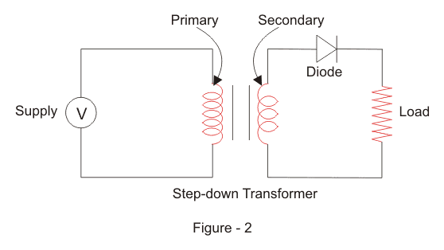

* We’ll now go through the process of how a half-wave rectifier converts an AC voltage to a DC output.First, a high AC voltage is applied to the to the primary side of the [step-down transformer](https://www.electrical4u.com/step-down-transformers/) and we will get a low voltage at the secondary winding which will be applied to the diode.During the positive half cycle of the AC voltage, the diode will be forward biased and the current flows through the diode.During the negative half cycle of the AC voltage, the diode will be reverse biased and the flow of current will be blocked.
* The final output voltage waveform on the secondary side (DC) is shown in figure 3 above.

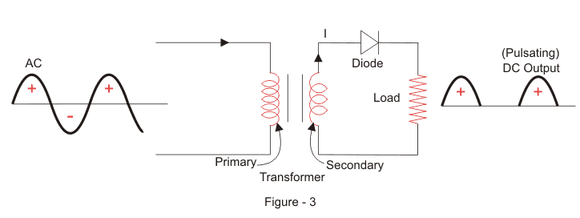

* We’ll focus on the secondary side of the circuit. If we replace the secondary transformer coils with a source voltage, we can simplify the circuit diagram of the half-wave rectifier as:

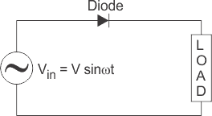

* Now we don’t have the transformer part of the circuit distracting us.For the positive half cycle of the AC source voltage, the equivalent circuit effectively becomes:

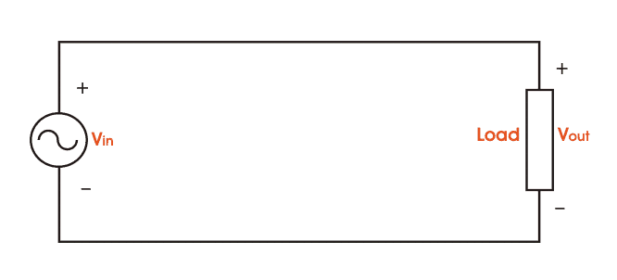

* This is because the diode is forward biased, and is hence allowing current to pass through. So we have a closed circuit.But for the negative half cycle of the AC source voltage, the equivalent circuit becomes:

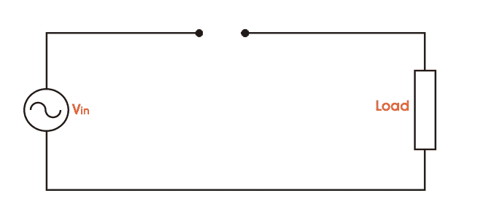

* Because the diode is now in reverse bias mode, no current is able to pass through it. As such, we now have an open circuit. Since current can not flow through to the load during this time, the output voltage is equal to zero.This all happens very quickly – since an AC waveform will oscillate between positive and negative many times each second (depending on the frequency).Here’s what the half wave rectifier waveform looks like on the input side (Vin), and what it looks like on the output side (Vout) after rectification (i.e. conversion from AC to DC):

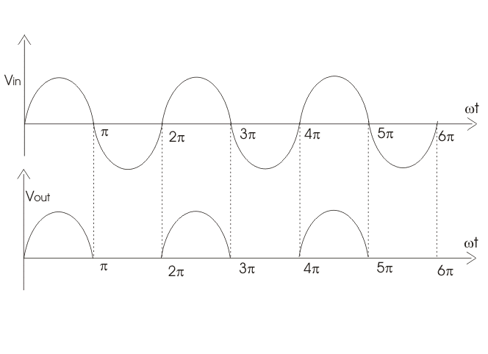

* This is a half-wave rectifier which only allows the positive half-cycles through the diode, and blocks the negative half-cycle.The voltage waveform before and after a positive half wave rectifier is shown in figure 4 below.

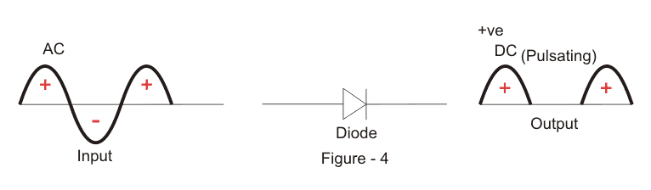

* Conversely, a negative half-wave rectifier will only allow negative half-cycles through the diode and will block the positive half-cycle. The only difference between a posive and negative half wave rectifier is the direction of the diode.

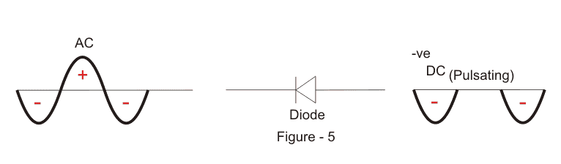

**Efficiency of Half Wave Rectifier**

* Rectifier efficiency (η) is the ratio between the output DC power and the input AC power.



* The formula for the efficieny is equal to:
* The efficiency of a half wave rectifier is equal to 40.6% (i.e. ηmax = 40.6%)
* **Output DC Voltage**
* The output voltage (VDC) across the load [resistor](https://www.electrical4u.com/what-is-resistor/) is denoted by:



**Advantages of Half Wave Rectifier**

* The main advantage of half-wave rectifiers is in their simplicity. As they don’t require as many components, they are simpler and cheaper to setup and construct.
* As such, the main advantages of half-wave rectifiers are:
* Simple (lower number of components)
* Cheaper up front cost (as their is less equipment. Although there is a higher cost over time due to increased power losses)

**Disadvantages of Half Wave Rectifier**

* The disadvantages of half-wave rectifiers are:
* They only allow a half-cycle through per sine wave, and the other half-cycle is wasted. This leads to power loss.
* They produces a low output voltage.
* The output current we obtain is not purely DC, and it still contains a lot of ripple (i.e. it has a high ripple factor)

**Applications of Half Wave Rectifier**

* Half wave rectifiers are not as commonly used as [full-wave rectifiers](https://www.electrical4u.com/full-wave-rectifiers/). Despite this, they still have some uses:
* For rectification applications
* For signal demodulation applications
* For signal peak applications

**Full Wave Rectifier**

* Like the half wave circuit, a full wave rectifier circuit produces an output voltage or current which is purely DC or has some specified DC component. Full wave rectifiers have some fundamental advantages over their half wave rectifier counterparts. The average (DC) output voltage is higher than for half wave, the output of the full wave rectifier has much less ripple than that of the half wave rectifier producing a smoother output waveform.
* In a **Full Wave Rectifier** circuit two diodes are now used, one for each half of the cycle. A multiple winding transformer is used whose secondary winding is split equally into two halves with a common centre tapped connection, (C). This configuration results in each diode conducting in turn when its anode terminal is positive with respect to the transformer centre point C producing an output during both half-cycles, twice that for the half wave rectifier so it is 100% efficient as shown below.

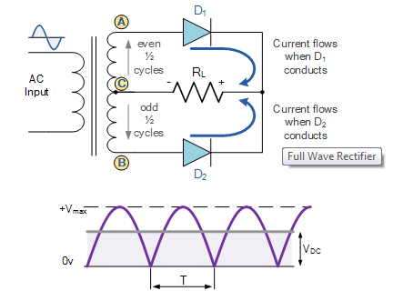

* The full wave rectifier circuit consists of two *power diodes* connected to a single load resistance (RL) with each diode taking it in turn to supply current to the load. When point A of the transformer is positive with respect to point C, diode D1 conducts in the forward direction as indicated by the arrows.When point B is positive (in the negative half of the cycle) with respect to point C, diode D2 conducts in the forward direction and the current flowing through resistor R is in the same direction for both half-cycles. As the output voltage across the resistor R is the phasor sum of the two waveforms combined, this type of full wave rectifier circuit is also known as a “bi-phase” circuit.

**The Full Wave Bridge Rectifier**

* Another type of circuit that produces the same output waveform as the full wave rectifier circuit above, is that of the **Full Wave Bridge Rectifier**. This type of single phase rectifier uses four individual rectifying diodes connected in a closed loop “bridge” configuration to produce the desired output.The main advantage of this bridge circuit is that it does not require a special centre tapped transformer, thereby reducing its size and cost. The single secondary winding is connected to one side of the diode bridge network and the load to the other side as shown below.

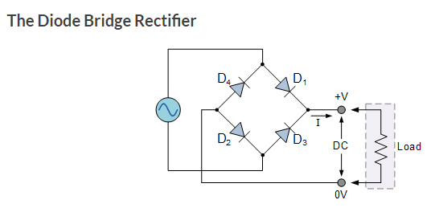

* The four diodes labelled D1 to D4 are arranged in “series pairs” with only two diodes conducting current during each half cycle. During the positive half cycle of the supply, diodes D1 and D2 conduct in series while diodes D3 and D4 are reverse biased and the current flows through the load as shown below.During the negative half cycle of the supply, diodes D3 and D4 conduct in series, but diodes D1 and D2 switch “OFF” as they are now reverse biased. The current flowing through the load is the same direction as before.

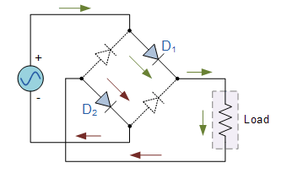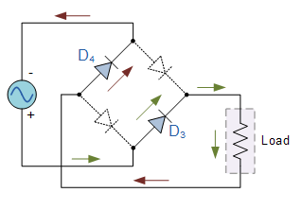

**Control rectifiers with R,L,C loads**

Single-phase Half-wave Circuit with RL Load

* A single-phase half-wave thyristor circuit with RL load is shown in Fig.

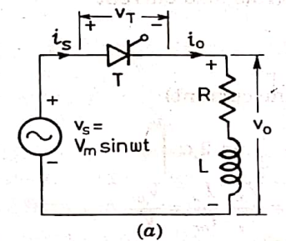

* At wt = α, thyristor is turned on by gating signal The load voltage vo at once becomes equal to source voltage vs as shown. But the inductance L forces the load, or output, current io, to rise gradually. After some time, io reaches maximum value and then begins to decrease. At wt = π, Vo, is zero but io, is not zero because of the load inductance L. After wt =π , SCR is subjected to reverse anode voltage but it will not be turned off as load current io, is not less than the holding current.

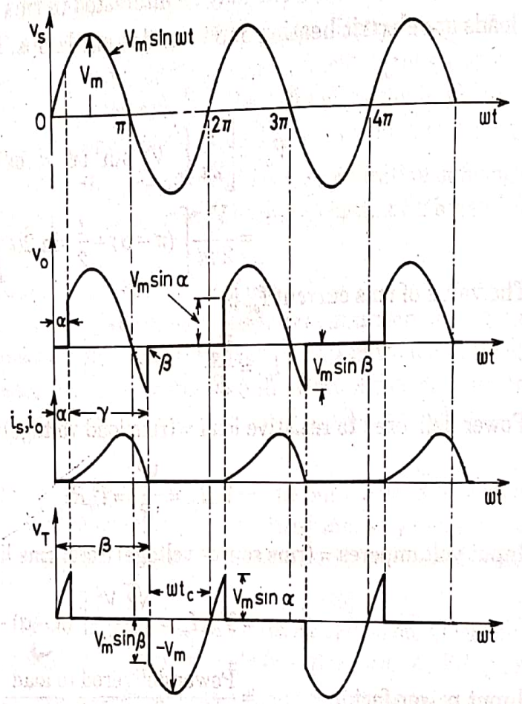

* At some angle β>π , io reduces to zero and SCR is turned off as it is already reverse biased. After wt =β, vo= 0 and io = 0. At wt = 2π+ α, SCR is triggered again, vo is applied to the load and load current develops as before.Angle βis called the extinction angle and (β-α) = γ is called the conduction angle.voltage equation for the circuit of Fig. when T is on, is



**Single-phase Half-wave Circuit with RLE Load**

* A single-phase half-wave controlled converter with RLE load is shown in Fig.

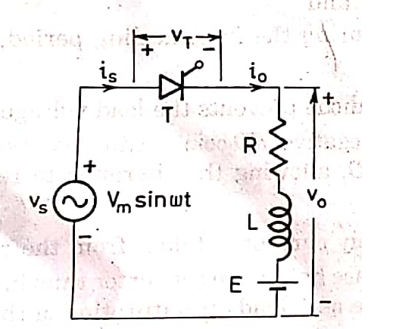

* The counter emf E in the load may be due to a battery or a dc motor. The minimum value of firing angle is obtained from the relation



* This is shown to occur at an angle θ1, in Fig, where In case thyristor T is fired at an angle α<θ1, then E>Vs SCR is reverse biased and therefore it will not turn on. Similarly, maximum value of firing angle is θ2= π-θ1, During the interval load current io, is zero, load voltage vo= E and during the time io is not zero, vo, follows vs curve.



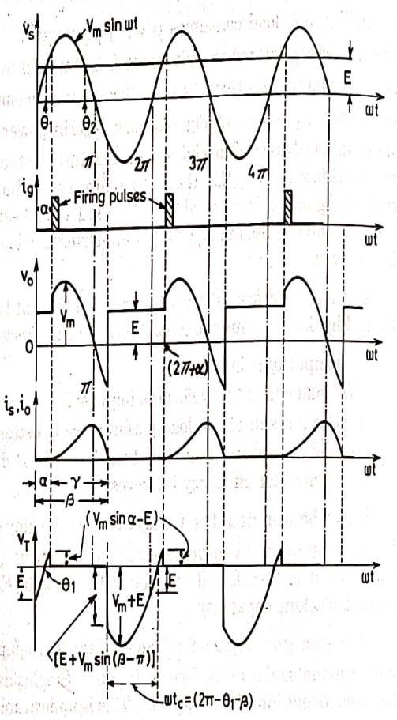

* For the circuit of Fig. with SCR T on, KVL gives the voltage differential equation as



**Full-wave Converter with RL load**

* The circuit diagram of a single-phase full-wave converter using a centre-tapped transformer is shown in Fig. When terminal **a** is positive with respect to **n,** terminal **n** is positive with respect to **b**. Therefore, van = vnb or van = - vbn as n is the mid-point of secondary winding.

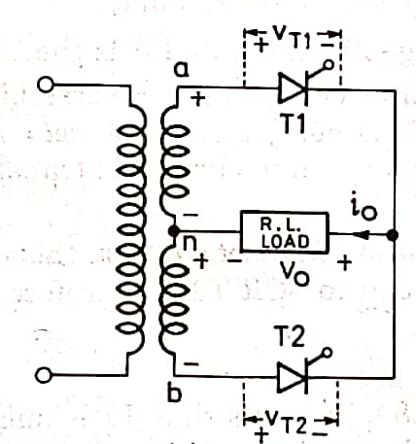

* Equivalent circuit of this arrangement is shown in Fig. It is assumed here that load, or output, current is continuous and turns ratio from primary to each secondary is unity.

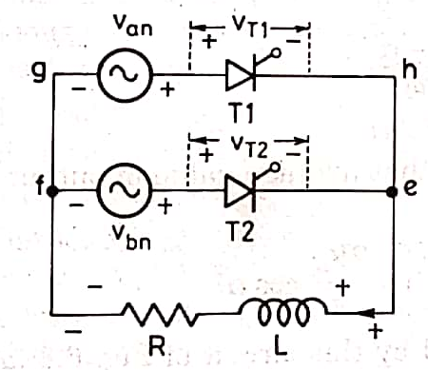

* Thyristors T1 and T2 are forward biased during positive and negative half cycles respectively ; these are therefore triggered accordingly. Suppose T2 is already conducting. After wt = 0, Van is positive, T1 is therefore forward biased and when triggered at delay angle α, T1 gets turned on. At this firing angle α, supply voltage 2Vmsin α reverse biased T2, this SCR is therefore turned off

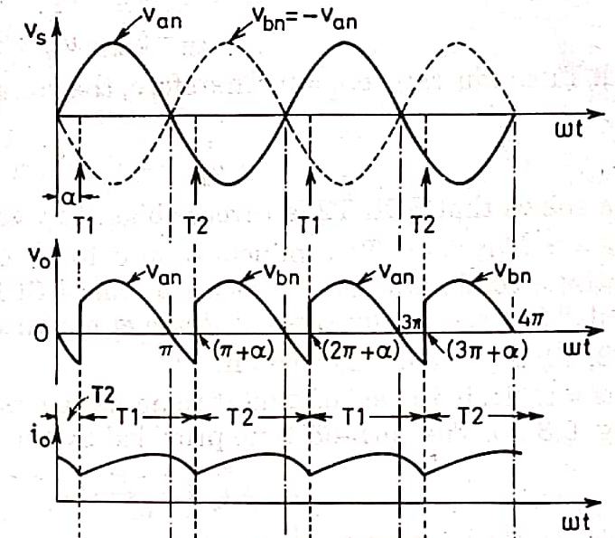

* Here T1 is called the incoming thyristor and T2 the outgoing thyristor.As the incoming SCR is triggered, ac supply voltage applies reverse bias across the outgoing thyristor and turns it off. Load current is also transferred from outgoing SCR to incoming SCR. This process of SCR turn off by natural reversal of ac supply voltage is called natural or line commutation.

**Full-wave Converter with RLE load**

* A single-phase full converter bridge using four SCRs is shown in Fig. The load is assumed to be of RLE type, where is the load circuit emf. Voltage E may be due to a battery in the load circuit or may be generated emf of a dc motor. Thyristor pair T1, T2 is simultaneously triggered and π radians later, pair T3, T4 is gated together. When a is positive with respect to b, supply voltage waveform is shown as vab in Fig.When b is positive with respect to a, supply voltage waveform is shown dotted as vba. Obviously, vab = - vba.The current directions and voltage polarities shown in Fig. are treated as positive

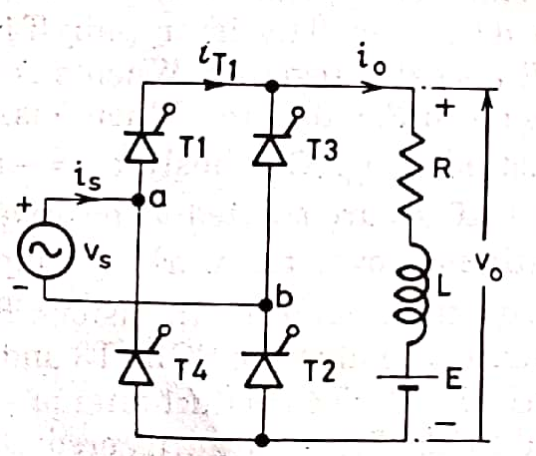

* Load current or output current io is assumed continuous over the working range ; this means that load is always connected to the ac voltage source through the thyristors. Between wt = 0 and wt = α; T1, T2 are forward biased through already conducting SCRs T3 and T4 and block the forward voltage. For continuous current, thyristors T3, T4 conduct after wt= 0 even though these are reverse biased. When forward biased SCR T1, T2 are triggered at wt =α, they get turned on. As a result, supply voltage Vmsinα immediately appears across thyristors T3, T4 as a reverse bias, these are therefore turned off by natural, or line, commutation. At the same time, load current i0 flowing through T3, T4 is transferred to T1, T2 at wt = α.

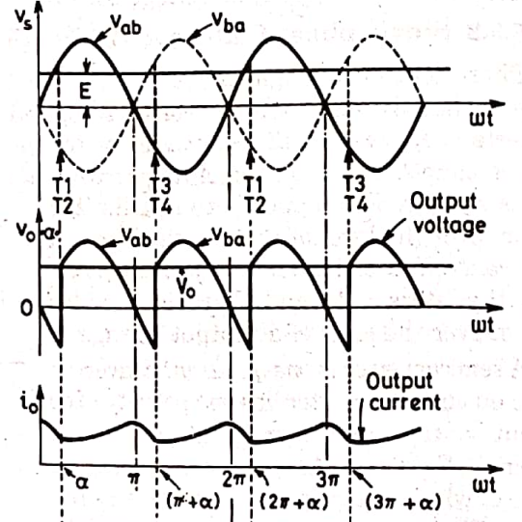

* Note that when T1, T2 are gated at wt= α, these SCRS will get turned on only if
* Thyristors T1, T2 conduct from wt = α to π+α.
* In other words, T1, T2 conduct for π radians.



* Likewise, waveform of current iT1 through T1 (or iT2 through T2) is shown to flow π radians in Fig.
* At at wt= π+α, forward biased SCRs T3 ,T4 are triggered.
* The supply voltage turns off T1, T2 by natural commutation and the load current is transferred from T1, T2 to T3, T4.if α > 90°, Vo is negative. This is illustrated in Fig.
* Where α is shown greater than 90°. In this figure, average terminal voltage Vo is negative. If the load circuit emf E is reversed, this source E will feed power back to ac supply. This operation of full converter known as inverter operation of the converter.

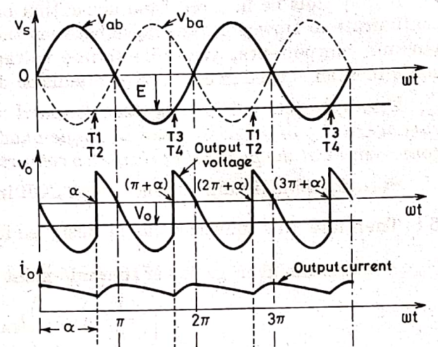

* The full converter with firing angle delay greater than 90° is called line-commutated inverter.During 0 to α, ac source voltage vs is positive but ac source current is is negative, power therefore flows from dc source to ac source. From α to π, both vs and is, are positive, power therefore, flows from ac source to de source. But the net power flow is from dc source to ac source, because π-α < α in Fig.In converter operation, the average value of output voltage Vo must be greater than load circuit emf E. During inverter operation, load circuit emf when inverted to ac must be more than ac supply voltage.In other words, dc source voltage E must be more than inverter voltage Vo only then power would flow from dc source to ac supply system.But in both converter and inverter modes, thyristors must be forward biased and current through SCR must flow in the same direction as these are unidirectional devices. This is the reason output current io is shown positive in Fig.